**APPLETON EVENING/MENASHA LIONS**

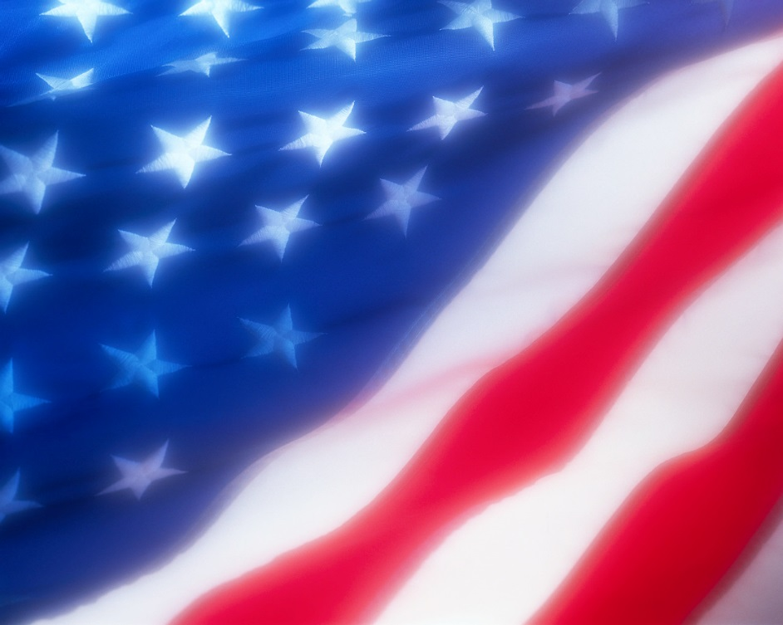

**President-Menasha Lions**

**Lion Pete LaValle**

**804 Arthur St, Menasha, WI 54952**

**920-725-5898**

**November, 2014 GOD BLESS AMERICA Issue 11**

**President-Appleton Evening Lions President-Menasha Lions**

**Lion Kevin Eckes Lion Pete LaValle**

**1125 E Melrose Ave, Appleton, WI 54911 804 Arthiur St, Menasha, WI 54952**

**920-574-6574 920-725-5898**

**We meet at Mark’s East Side, 1405 E. Wisconsin Ave in Appleton, on the 2nd and 4th Tuesday of each month, unless otherwise stated. Our dinner meeting starts at 6:30 pm, with a program to follow. The AE Board meets the 1st meeting of each month at 5:45 pm.**



**Lion Tom Nov 04**

**Lion Ron Nov 09**

**Lion Nubs Nov 18**

**Lion Pete Nov 24**

**Lion Jess Nov 24**

**$$$$$$$$$$$$$$$$$$$$$$$$$$$$$$$$$$$$**

Do we have a deal for you! Save over $60 in Pizza King pizzas & subs when you buy a Pizza King Card for $10. Not a better pizza or sub. No expiration. **$$$$$$$$$$$$$$$$$4$$$$$$$$$$$$$$$$$$$**

This

Please bring a If you forgot birthday raffle in your birthday month, you can if you

Birthday Lions:

Don’t forget to bring a gift for the birthday raffle to the next meeting. This helps pay for the speaker’s meal and meeting expenses.

**HAPPY BIRTHDAY, LIONS**



☺ What’s Up!

**November 11 -**

**5:45pm – Board Mtg**

**6:30pm – Regular Mtg**

**Prog Chair– Lion Pam**

**Prog – Girl Scout**

**Bronze Award**

**November 24 -**

**6:30pm – Regular Mtg**

**Prog Chair – Lion Chuck**

**Prog –Volunteer Center**

**November 11 (Veterans Day)** – We will have two speakers for the evening, Charlotte V will speak on receiving her Bronze Award from the Girl Scouts and Lion Chuck will have a short presentation on Veteran’s Day. Board Meeting will meet at 5:45 pm sharp.

**November 14,15** – B-1 Convention, Oshkosh.

**November 24 (Monday**) – Note this is on Monday. We anticipated being in Appleton’s Christmas Parade, Tuesday, Nov 25, (our regular meeting night) so our meeting was moved to Monday, the 24. Our entry was not picked for the parade but it was decided to leave the meeting on the 24since things were already set up. Hope you can make it. Speaker Carol B is from the Volunteer Center of East Central WI. Enjoy the Christmas Parade.

**November 26** – First day of Bell Ringing for the Salvation Army. Ringing takes place at Festival Foods on Northland Ave. Schedule is set up for 2 hour blocks of time starting at 8 am and going until 8 pm. If you would like to Ring, contact Lion George at 731-3447. There are still 2 hour blocks that need to be filled or join up with another that is already signed up.

**November 27 – Happy Thanksgiving**

**December 1, 2, 3, and 4** – Salvation Army Bell Ringing continues; same times, same place. Contact Lion George. Needed: more ringers.

**November ?** – Due to not having a firm count by the Appleton schools, the Dictionary Project is on hold. The date should be solidified soon. If you would like to help Lion Jess, Chuck & Kevin hand out dictionaries to the third graders, call Lion Chuck, 731-3447.

**9** – **Christmas Party**, form included

**WHAT’S UP!**

**m**

**IMPORTANT DATES TO REMEMBER**

**Nov ? - Dictionaries**

**Nov 14-15 – B-1 Convention in Oshkosh**

**Nov 26 – Ringing Bells/Salvation Army**

**Dec 1-4 – Ringing Bells/Salvation Army**

**Dec 9 – Christmas Party**

**Dec 17 – Serving at the Warming Shelter**

**Dec 25 – Merry Christmas**

**Jan 8 – Rose Sale Kick-Off Dinner**

**Jan 13 – First Meeting of the New Year**

“WE SERVE”



**October 4 & October 18** were our two Brat Fries for the month. Lions George, Wayne, Nubs, Ed, Rich, Marie, John, Ron, Mike L, Bob and Carl worked the first Fry. Each club made $145. On the 18, Lions George, Pete, Mike L, Nubs, John, Rich, Win & Bob manned the “hut”. Each club made $131.50. A BIG ROAR to you Lions! Thanks to the Chair - Lion George. The Leukemia & Lymphoma Society’s “Light The Night” walk was on **October 10**. Lions Chuck, Pam, Pete & Ed helped assemble 500 battery powered lanterns before the event. Chair - Lion Pam. Our first meeting of the month, **October 14,** started with the board meeting. Minutes for the meeting are included in this mailing. Our speaker was Nikki Gingras, Mentoring Program Coordin- ator for the Outagamie County Mentoring Program. Youth are 6-17 years of age and are involved in the juvenile justice or child welfare system. Chair – Lion Pam. There were winners of the AE raffle, wonder who? And Lion Fred missed the joker in the Menasha raffle by picking the 9 of diamonds. The next night, **October 15**, was the B-1 Zone meeting, hosted by the Appleton Noon Lions at the Grand Meridian. Lions Chuck, Kevin, Jim C, Mike L, Pete, & Ed attended. Speaker for the night was DG Gary S**. October 17, 18, 23, 24, 25** were the nights the Haunted House was open. Lion Wayne was chair & he also put an incredible amount of time into it. Other workers & scarers were Lions Jim C, Chuck, Jim S, Kevin, Carl, Renee, Kim and Chris with daughters Sammy & Morgan, our friend Mitch, Lion Pete & Mike L. Great job everyone. The **October 28** speakerwas Earl from Wolf Education International.Very informative. Thanks Lion Jess for being the program chair. Lion Pam won the AE raffle & Lion Kevin missed winning the Menasha 50/50 raffle.



Lion Tom Lion Chuck Lion Linda Lion Kevin Lion Mike M and Kim

**NEWSPAPER EDITOR Lion Pam M**

**WEBMASTER Lion Mike M**

Have any news, contact Lion Pam at

731-3447 or pmompier@sbcglobal.net.