**APPLETON EVENING/MENASHA LIONS**

**President-Menasha Lions**

**Lion Mike Loeper**

**1714 S Perkins St, Appleton, WI 54914**

**920-733-0265**

**February, 2014 GOD BLESS AMERICA Issue 02**

**President-Appleton Evening Lions**

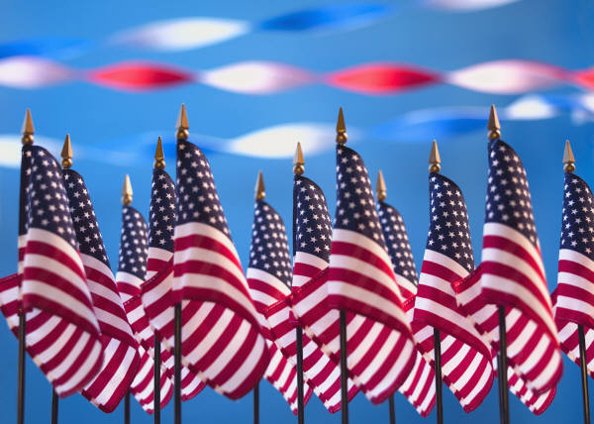

**Lion Jimmy Christman**

**P O Box 2372, Appeton,WI 54912**

**920-915-3236**

**We meet at Mark’s East Side, 1405 E. Wisconsin Ave in Appleton, on the 2nd and 4th Tuesday of each month, unless otherwise stated. Our dinner meeting starts at 6:30pm, with a program to follow. The AE Board meets the 1st meeting of each month at 5:45pm.**





Lion Kevin 02/12

Lion Verlyn 02/15

Lion Fred 02/20

**HAPPY BIRTHDAY TO YOU**

Lion

**$$$$$$$$$$$$$$$$$$$$$$$$$$$$$$$$$$$$**

Do we have a deal for you! Save over $60 in Pizza King pizzas & subs when you buy a Pizza King Card for $10. Not a better pizza or sub. No expiration. **$$$$$$$$$$$$$$$$$$$$$$$$$$$$$$$$$$$$**

What’s Up!

**IMPORTANT DATES TO REMEMBER**

**Feb 11** – Valentine’s Party

**Mar 20 –** Zone Meeting, co-chaired by

Appleton Evening and Menasha

**Mar 27** – Rose Exchange

**Apr 01** – Geranium Sale Starts

**Apr 11** – Rose Pick-up and Friday Delivery

**Apr 12** – Rose Delivery

**Apr 13** – **Appleton Evening’s 50th**

**Anniversary Party**

**May 09** **–**Tentative Date Geranium Pickup

**May 15/16** - State Conv. - Wisconsin Dells

**May 26** – Memorial Day Parade

**ARCHIVES**

**\*Jan. 9 - Rose Sale** kick-off dinner at the American Legion started off the calendar year. Lions Tom & Pam and friend Tim attended the meeting. We received the **Rose**  cards, info and materials for the sale.

**\*Jan. 14 -** **Board Meeting** minutes enclosed**. Dinner** M**eeting** followed. No raffles, no announcements, no speaker but there was great food and friendship. Due to the bad weather, the count for the meeting was 6.

**\*Jan. 15 - Zone Meeting** at Headliners in Neenah was hosted by the Neenah Lions. Lions Jimmy, Wayne, Pete, Mike L and Dean attended the meeting. Lions Wayne, Pete, Mike L each received the Knight of Sight award from the Larsen Winchester Lions, along with Lions Ed, Nubs who are snow-birding and not in attendance. Congratu-lations to these 5 lions. Lion Dean was the speaker and the program’s message in a few words was “WE SERVE” not - we sell.

**\*Jan. 19 – Fairwater 50th Anniversary Party** was attended by Lions Jimmy and Kevin, supporting the other clubs in our District. Around 75 people attended with a nice chicken and all the fixins dinner. PID Wayne Heiman was the speaker. Lion Jimmy said it was about 3 ½ hours, with driving - 6 hours.

**\*Jan. 28 – Dinner Meeting** was cancelled by an executive order issued by our President!!!

This was due to the weather. Our next meeting is the Valentines Party at Stone Toad Social hour at 6 pm and dinner at 7 pm.

**What’s up!**

**Rose Sale**

Everyone should have received **Rose** Cards and an information sheet for the sale which runs thru March 20. As Lion Tom has said in the past, SELL, SELL, SELL. This is our best fundraiser of the year and also a great opportunity for us as a club considering that our club is not the chair of this project. A big thanks to the Grand Chute Lions for their hard work in getting this altogether. If you have not or need more **Rose** cards, contact Lion Chuck at 731-3447



**PRAYER REQUESTS**

Lion Kevin and Family

Lion Verlyn and Jane

Lion Chuck

Lion George



 OO

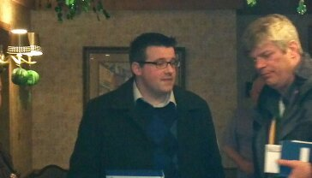

**Our new Web**

**Master**

**Lion Mike M**

**USEFUL WEB ADDRESSES**

Md27b1 m27b1.org

Lions International lionsclubs.org

Wi Lions Foundation wlf.info

Lions Eye Bank of WI lebw.org

Lions Pride lionspride.org

Lions Camp wisconsinlionscamp.com

AE Lions appletoneveninglions.com

**2014 BRAT FRYS**

**April 19**

**May 10**

**June 07**

**June 28**

**July 03**

**July 26**

**August 9**



